Low Level Design (Apply for job module)

Project Code | Team2
Project Name | Online Recruitment Management System

Prepared/Modified by | Role | Date of Preparation
Akash Bansal | Senior Software Analyst | 11/11/2017
Reviewed by | Role | Date of Review
Vaishali Srivastava | Consultant | 16/11/2017
Approved by | Role | Date of Approval
Vishal Mali | Senior Consultant
Circulation List | akash.bansal@capgemini.com,  mvallamk@capgemini.com,  kaustav.saha@capgemini.com,  mohit.deshmukh@capgemini.com | Version Number of the template:1.0
Version Number | 1.3

Table of Contents

1. Description Of The Unit 3
2. References 4
3. Dependencies / Assumptions 5
4. Class Diagrams 6
5. Sequence Diagrams 7
6. Design Components 8
6.1 List Of UI Components 8
6.2 List Of Design Classes 8
7. Re-Usable Routines/Components 9
8. Messages 10
9. Configuration Files 11
10. Crud Matrix Table 12
11. Data Mapping Matrix 13
12. Action Flow Matrix 14
13. Stored Procedures 15
14. Program Specification / Pseudo Code 16
REVISION HISTORY OF THE WORK PRODUCT 17

Description Of The Unit

The Apply for job module is basically used by the candidate of the system, where he can apply for the jobs that are listed in serach jobs module.

After the execution of search jobs module, the candidate will have a list of jobs that have been posted by the company that satisfies his/her criteria. Here, the candidate can read about the job requirements and click on the apply button that will insert the candidate’s ID, job ID and company ID into the database. So that means that the candidate has successfully applied for the job. After clicking on apply, he/she will be redirected to the home page with a success message with the respective job ID.

References

Reference | Description
Repository reference | https://github.com/mvallamk/Group-2_OnlineRecruitmentSystem/tree/master/OnlineRecruitmentSystem-Group-2
Class Diagram | /Project Documents/Design Documents/HLD/Class Diagrams
UTP | /Project Documents/Requirements/Case Study/OnlineRecruitmentManagementSystem.doc
DB Design | /Project Documents/Test Plan/UTP/Test Cases/AddProduct /UTP_AddPersonalDetails_Module.xlsm

Dependencies / Assumptions

Dependencies:
Apply for jobs module depends on the Login module in such a way that, the candidate is only able to apply for job when he is logged in.
If the customer is not logged in then he/she will be asked to login.

Assumptions:
Customer details are stored in a database.
Job Requirement details are stored in database.

Class Diagrams

Class Diagram

Sequence Diagrams

Sequence Diagram
NA

Design Components

List Of UI Components
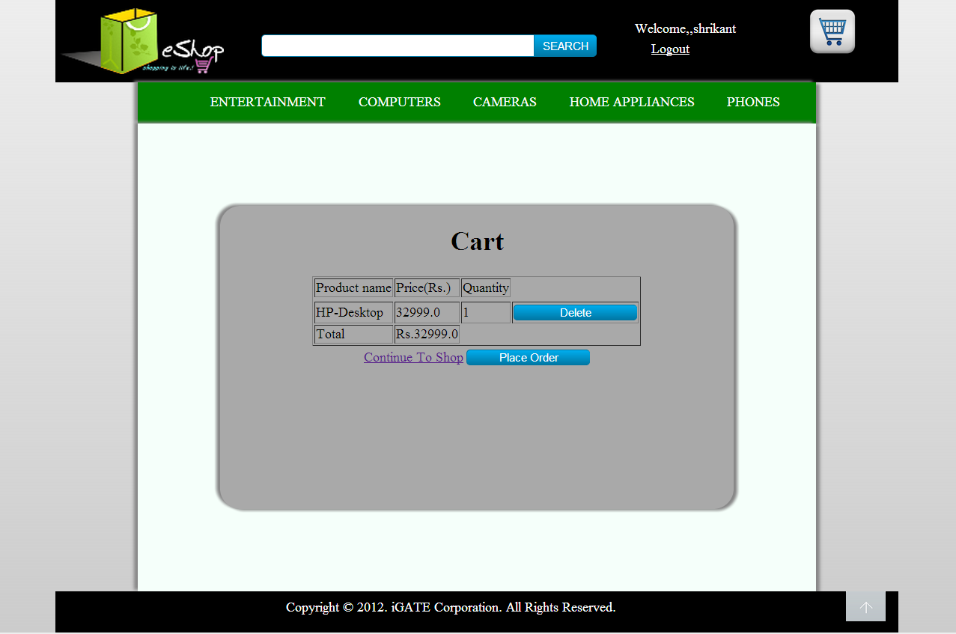

List Of Design Classes

Sr. No. | LLD Name | Class Name | Method Name | Method Description
1 | Apply For Jobs Module | Login | Appropriate getters and setters methods | Getters retrieve the property values and setters set the property values
2 | Apply For Jobs Module | RecruitmentController | applyForJob(@RequestParam("jobID") String jobId,@RequestParam("companyId") String companyId ,Model model):String | Sets the model attribute.  Calls insertApplyJob() of RecruitmentServiceImpl class and insert all the job applied details into the database.
3 | Apply For Jobs Module | RecruitmentServiceImpl | insertApplyJob(JobApplied jobApplied):void | Calls insertApplyJob() of RecruitmentDAOImpl class to persist the values.
4 | Apply For Jobs Module | RecruitmentDAOImpl | insertApplyJob(JobApplied jobApplied):void | Insert the job applied details into the database.

Re-Usable Routines/Components

Re-Usable Routines/Components

- CSS files
- Logger properties files

8. MESSAGES

#. | Type | Message Text

9. CONFIGURATION Files

File Name | Path | Description
jpaContext.xml | /Development/Source/OnlineRecruitmentSystem/resources | To configure database connection.
web.xml | /Development/Source/OnlineRecruitmentSystem/WebContent/WEB-INF | To configure the bean properties and request mapping.
servlet-config.xml | /Development/Source/OnlineRecruitmentSystem/WebContent/WEB-INF/config | To configure view resolver.
log4j.properties | /Development/Source/OnlineRecruitmentSystem/resources | To configure the logger.

Crud Matrix Table

# | Table Name | Create | Read | Update | Delete
1. | JobApplied | Y | N | N | N

Data Mapping Matrix

Sr. No. | Screen Label | Field Source | Field Type | Data Type | Max Length | Data Flow | Mandatory
1 | Apply | NA | Button | NA | NA | UI->D | NA

Legend
D → UI (Database to User Interface)
UI → D (User Interface to Database)
UI (User Interface Only)

Action Flow Matrix

Sr. No. | Action | Description | Process
1 | On click of Apply Button | Allows the candidate to apply for job. | The candidate has a list of jobs on the UI that matches his/her criteria. After clicking on apply button. Data about job applied will get inserted into the database and the candidate will be redirected to home page after successful operation.

Stored Procedures
# | Stored Procedure Name  (with Description) | Input/Out Parameters | Type | Size
1. | NA | NA | NA | NA

Program Specification / Pseudo Code

14.1 <ACTION: AddToCart_CLICK>

Pseudo Code:
- Client Side Scripting:
None

- Server Side Scripting:
BEGIN

IF Customer is not logged in
Navigate to Eshop_User_Login.

IF Customer is logged in

Call proceedToAddToCartPage(@ModelAttribute(value="product") Product product, @RequestParam(value="userQuantity") String userQuantity,Model model):String in Controller class

Navigate to Eshop_Customer_AddToCart page.

IF the cart is empty
Print message M1

END

14.2 <ACTION: Delete_CLICK>
Pseudo Code:
- Client Side Scripting:
None

- Server Side Scripting:
BEGIN
Call deleteItemFromCart (Model model) in Controller class
Delete an item from the list.
Reset the cartList.
Navigate to Eshop_Customer_AddToCart page.
END

14.3 <ACTION: ContinueToShop_CLICK>

Pseudo Code:
- Client Side Scripting:
None

- Server Side Scripting:
BEGIN
Call proceedToHomepage (Model model) in Controller class
Navigate to the Eshop_Customer_HomePage.
END

REVISION HISTORY OF THE WORK PRODUCT

# | Date | Version # | Section Changed | Details of changes made | Approved By
1 | 16/12/2013 | 1.0 | LLD prepared | N/A | Uma M Ponniamman
2 | 17/12/2013 | 1.1 | Reusable components,  Pseudo Code. | Unwanted Reusable components removed.  More specific control flow specified. | Uma M Ponniamman
3 | 17/12/2013 | 1.2 | Designed Classes,  Reusable components,  Reference | The Controller’s name is changed to ‘EshopController’.  Reusable Components added.  File name with relative path is added in the references section. | Uma M Ponniamman
4 | 20/17/2013 | 1.3 | Designed Classes,  Pseudo code | The method names in the designed class table and pseudo code are changed as per the class diagrams. | Uma M Ponniamman
5 | 24/12/2013 | 1.4 | Configuration files,UI Components | Paths of the configuration files is updated and UI components(Screen Shots) added. | Uma M Ponniamman

